FAST JV Module: Walkthrough Guide

- To create a JV, begin by clicking “Create a new Document” from the FAST Journal Vouchers home screen.
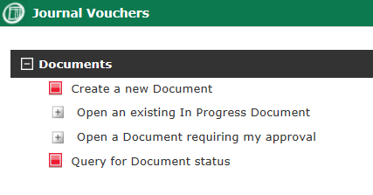

- Complete the JV header by giving the JV a date, reference, description, and details.

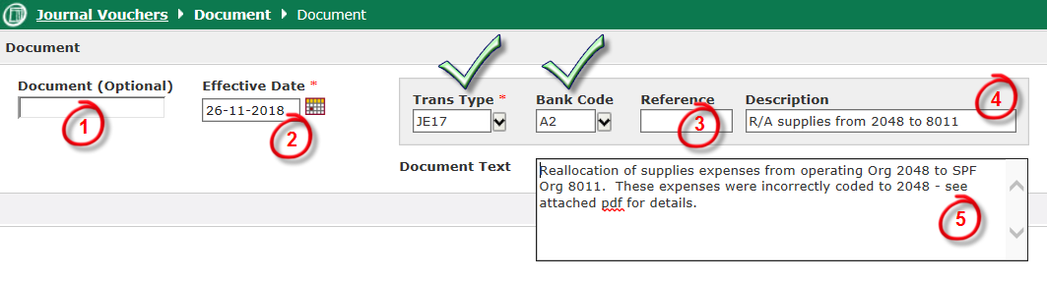
1 | Document Number | Leave as is. This should auto-populate once the JV is created.
2 | Effective Date | Enter the date that will be used for the JV – this is generally today’s date. Do not backdate JVs to a prior month; if the transaction relates to prior month activity, note this in the Document Text field.
3 | Reference | If you have a Invoice or JV reference number, enter it here. This can otherwise be left blank.
4 | Description (short) | Enter a brief description of the JV – one line at most.
5 | Document text (long) | Enter as much detail as you like regarding the nature of the transaction that is being booked.
 | Trans Type, Bank Code | Do not change; leave as default settings.

- Click on “Create Document” and begin to add JV transaction lines.
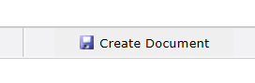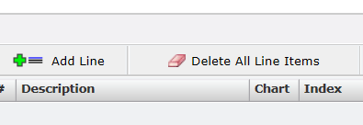

- Enter either the Index code or the Fund/Org code for your first line, then the Acct code.

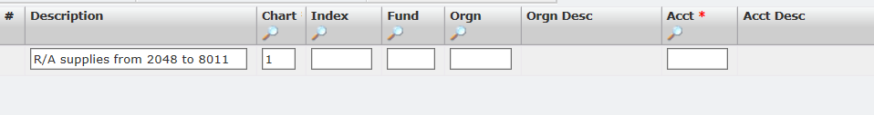

- If your JV relates only to revenue or expenses, you often do not need to enter the Fund/Prog. Only enter the Org and Acct codes, and the JV should auto-complete the Fund and Prog fields.
- You can use the icon to search for specific Fund/Org/Acct codes on each line.

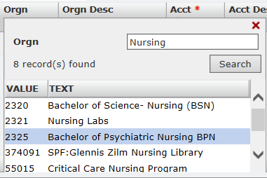
Next, complete the line by entering in the Debit or Credit amount, then click the icon to save. Repeat this step for each line within your JV request.

- Debit: This is the expense line, and should be matched with the Org that is gaining the expense, or losing its funds.

- Credit: This is the revenue line, and should be matched with the Org that is receiving the funds, or losing its expense.

After Adding a New Line:
- Update the Description text box if necessary
- Clear out the Index text box, if necessary
- Re-enter the new Org and Acct information for the next line item
- Clear out the PROG text box – this will be automatically updated
- Repeat these steps for each new line that is added

- Click on “Attach Additional Information” and attach all related backup documentation.

Examples of backup documents include:
  - Expense-related invoices or receipts
  - Internal reports
  - Funding letters
  - FAST extracts, as proof of incorrect coding
  - Emails between departments, indicating transfer details and authorization

If you are uploading an Excel import template, you should now select the “Excel Import” option and upload your completed Excel template.
- A blank Excel import template can be downloaded after clicking “Excel Import”:

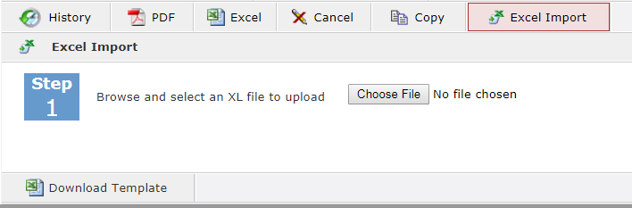

- If you are preparing both the Debit and Credit sides of the JV, verify that your Document is balanced, then click “Submit for Approval”.
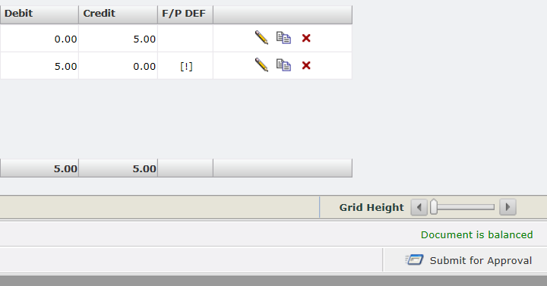

For multi-department JVs:
- If you are preparing the first side of the JV, verify that all of your lines have been added to the JV, then click “Submit for Approval”.
- If you are preparing the second side of the JV, verify that the “Document is balanced” text appears, then click “Submit for Approval”.

- On the Submission screen, the next step differs between Preparer and Approver.

- Preparers: Click on the to search for the other Preparer, or your DBM/Manager, then click “Submit”.
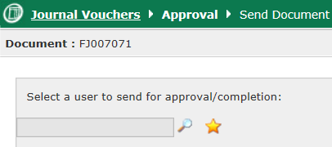

- Approvers: If changes are needed to the JV, click on “Return this Document” to have changes made to the JV by the Preparer. Otherwise, select “Send to Central Approval (FOR FINANCE USE ONLY)”, mark as Approved in the comment box, then click on Submit.
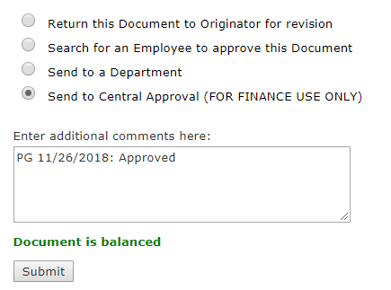

- Your FAST JV is now with Finance for processing. To check on the status of your JV, you can search for the JV number from the “Query for Document status” option located on the FAST JV home screen.
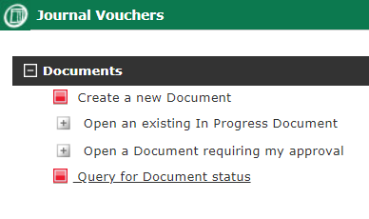

Troubleshooting / FAQ:

Q: I was not able to find my Fund/Org in the JV search screen.
A: This is most likely the result of one of the following scenarios:
- You can only view and post to Fund/Orgs over which you are authorized. If you lack authorization with a particular Fund/Org, you will not be able to see it via the JV or search screens. If you believe this to be the case, please contact Donald Do (donald.do@kpu.ca) or Paul Grewal (paul.grewal2@kpu.ca) within Finance.

- You may be attempting to post to a high-level Org that does not allow for data entry. In this case, you would need to be more specific in your search: eg. “Faculty of Health” is Org 1025, but this is a high-level Org that is not data-enterable, and would not appear as a search result. You would need to specify a lower Org within Org 1025: Faculty of Health to which to post. You can use the FAST Finance module to view a list of the lower level Orgs within your higher-level Org, if you do not know the exact name.

Q: How do I complete the Excel import template?
A: The Excel import template should be completed the same way as the actual FAST JV screen. Please note that only the fields below need to be completed in the template:
- COA: This field is always equal to “1”.
- Orgn, Acct, Description: These fields will need to be completed.
- Debit, Credit: Only one of these fields should be filled, per line.
The Fund field does not need to be filled out if you are moving revenue & expense items only. If left blank, FAST JV will use the default Fund for the Org that you identify.

Q: I am getting errors when I upload my Excel import template.
A: The Excel import template mimics the actual JV line entry screen, and is therefore subject to the same limitations as the JV module. As such you may receive similar errors, such as errors relating to:
- Attempting to post to an unauthorized Fund/Org
- Attempting to post to a non-data enterable Fund/Org
- Using a text description contains invalid characters (eg. @ $ % ^ & *)
- Using a text description that is too long (maximum of 35 characters is allowed)
If you receive an error, please view the PDF error log to determine which error you have received, and adjust your Excel import template accordingly.

